**3. Iteration (Unconditional loops)**

**Task 1:**

**Plan:**

1. For loop, loops through “I” 50 times.
2. while loop checks that user input is an integer.
3. User is asked to enter a time for pupil “I”.
4. Time is appended to a list.
5. User is asked to enter time for next pupil.
6. Repeats steps 2 to 5, until “I” has been looped through 50 times.
7. The average time is worked out by adding all the pupil’s times, then dividing by 50.

**Pseudocode:**

Print ("Enter the time in seconds for each pupil:")

Pupil 🡸 []

For I in range (1,51):

Time 🡸 True:

While time = True:

Try:

Print ("Pupil", i)

Time 🡸 input as integer ()

Pupil.append (time)

Except:

Print ("Not a valid time")

Average 🡸 sum(pupil) / len(pupil)

Print ("The average time was", round(average,2))

**Variables table:**

|  |  |  |
| --- | --- | --- |
| Variable name | Data type | Comment |
| Pupil | List | User input is appended |
| Time | Boolean | Used to validate if “time” is an integer. |
| Time | Integer | Stores user input as integer |
| Average | Float | Stores the calculated average of pupil |

**Screenshot evidence:**

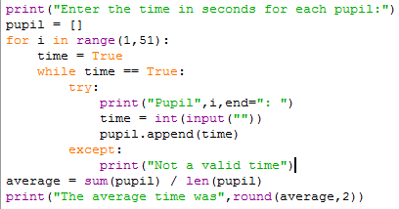in the screenshot to the left. A for loop, loops through a counter variable “I”, adding 1 to the counter after every iteration. Within the for loop is a while loop that checks that a variable named “time”, is an integer. If it is not, the user is asked to enter a value for time again. If time is an integer, then it’s value will be appended to a list variable “pupil”. Once the for loop has reached 50 iterations it will end. An average will then be calculated and stored in a variable called “average”. The average will be output as a float to 2 decimal places.

**Sample run (Output):**

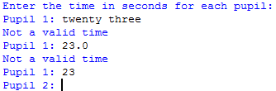in the screenshot to the left I enter the value “twenty three”, this is not excepted and I am asked to enter a value for pupil 1 again. This shows that the while loop with the try and except statements it working correctly, as I entered a string that than an integer. i then enter a float. And again it is not excepted and an error message is displayed. finally, I enter an integer, it is excepted and I am asked to enter a value for pupil 2.

**Flow charts:**

Time 🡸 True

Pupil.append(time)

START

No

END while

Yes

No

Output (error message)

Is time an integer?

Yes

While time is equal to True. Is time = True?

Output (“Pupil”, i)

For I in range (1,51). Is I 🡸 50?

Pupil 🡸 []

Time 🡸 input as integer

Yes

average 🡸 sum(pupil) / len(pupil)

END

Output ("The average time was", round(average,2))